

Heritage Treasures: An In-Depth Analysis of UNESCO World Heritage Sites in Tableau

Team ID : LTVIP2025TMID51205



## Activity 1.1: Countries per Region

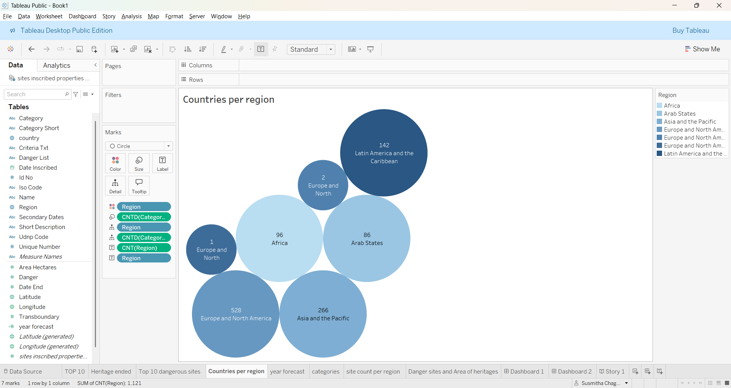

## Activity 1.2: Top 10 Regions by Area

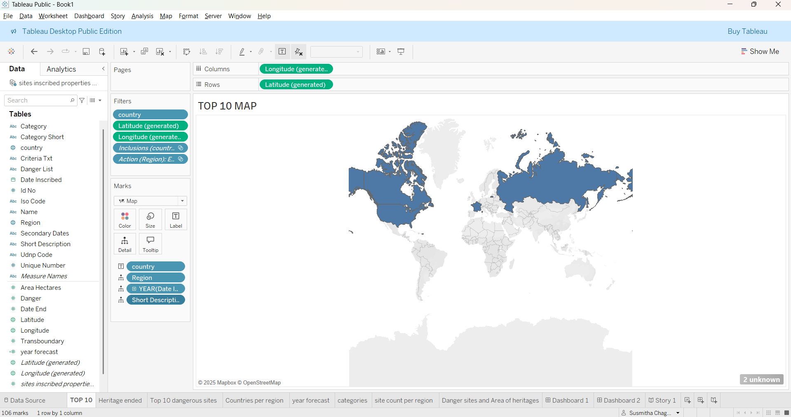

## Activity 1.3: Regions by Heritage Ended

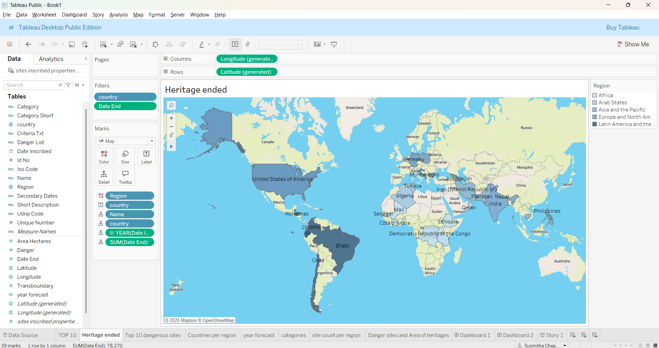

## Activity 1.4: Top 10 Danger Sites Prone to Extinction

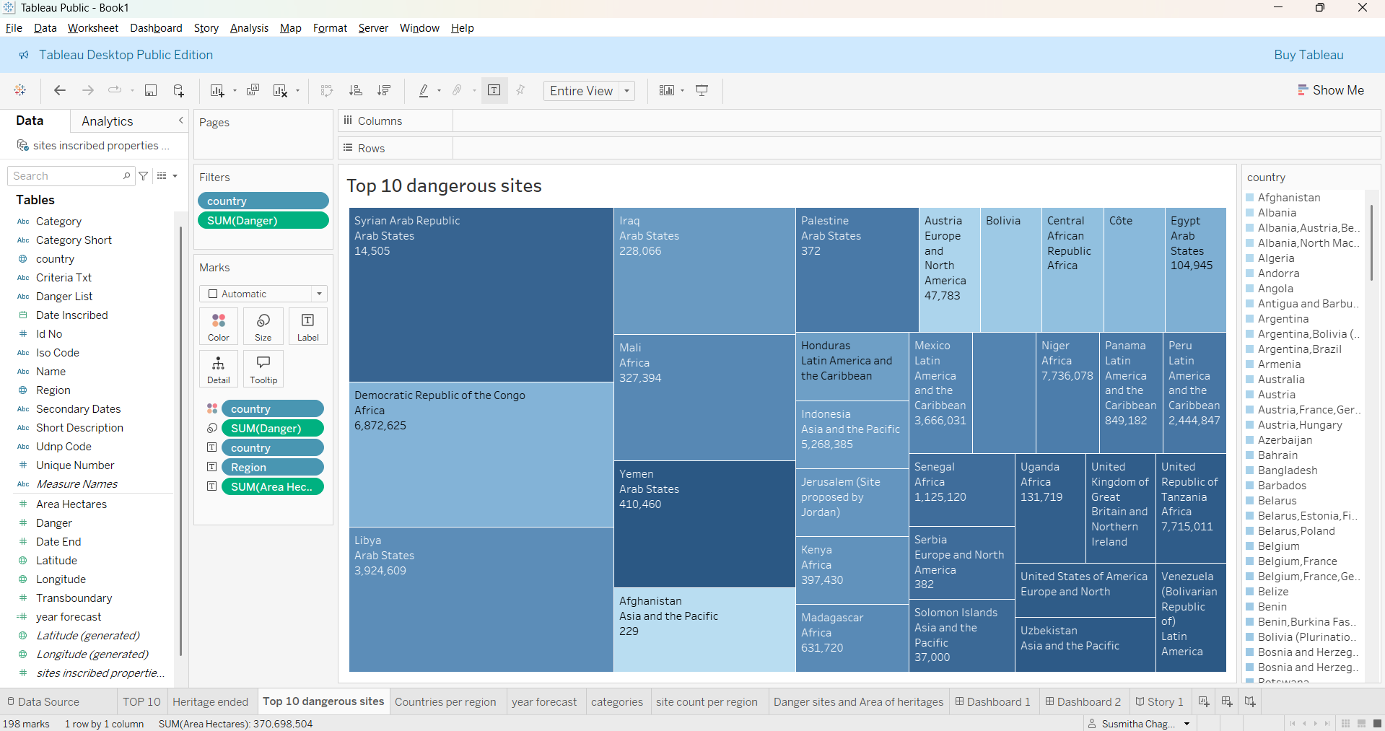

## Activity 1.5: Year Forecasting of Heritages

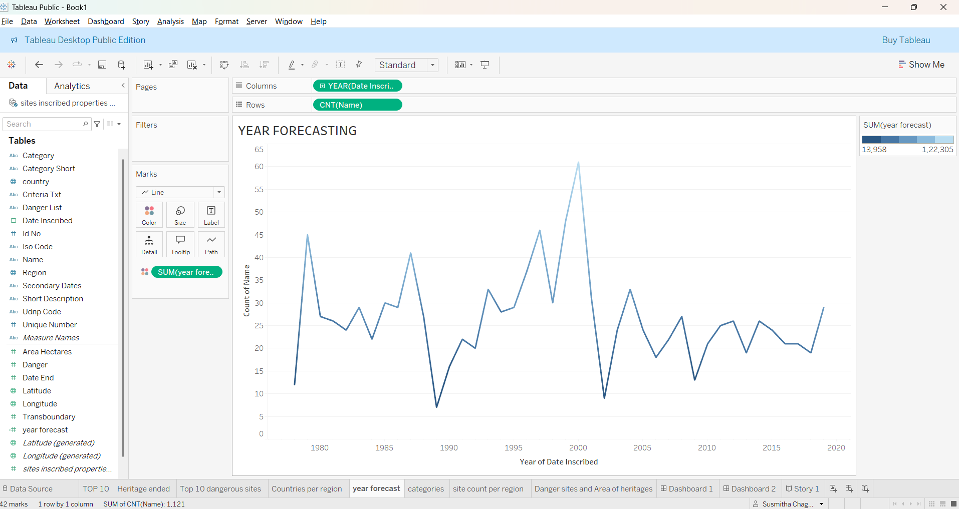

## Activity 1.6: Categories by Site Count

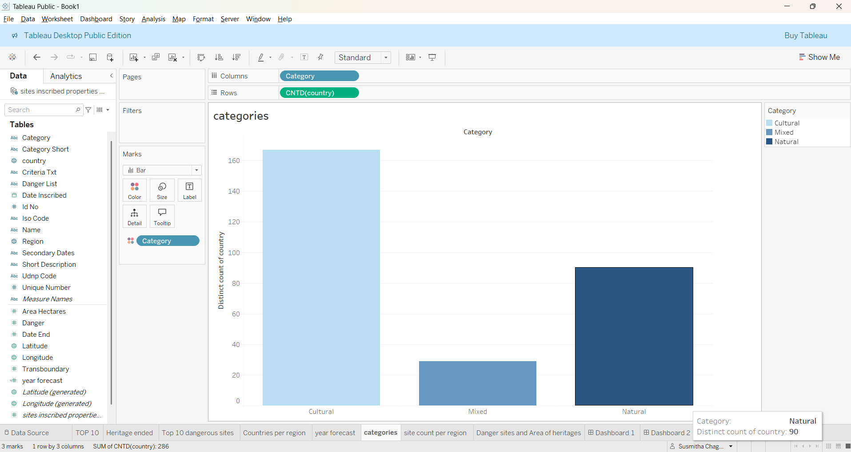

## Activity 1.7: Site Count per Region

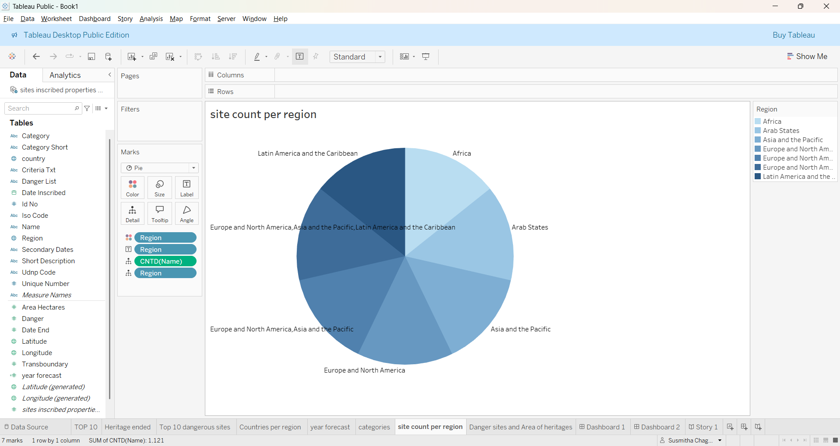

## Activity 1.8: Analysis of Danger Sites and Area of Heritages

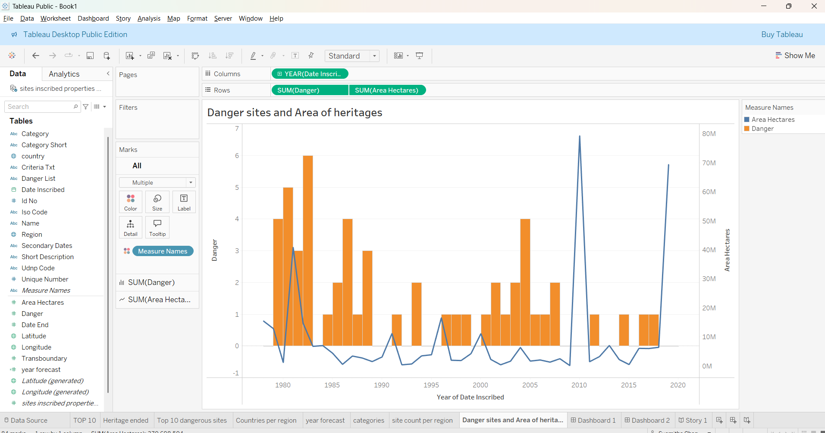

## Final Dashboard1 View

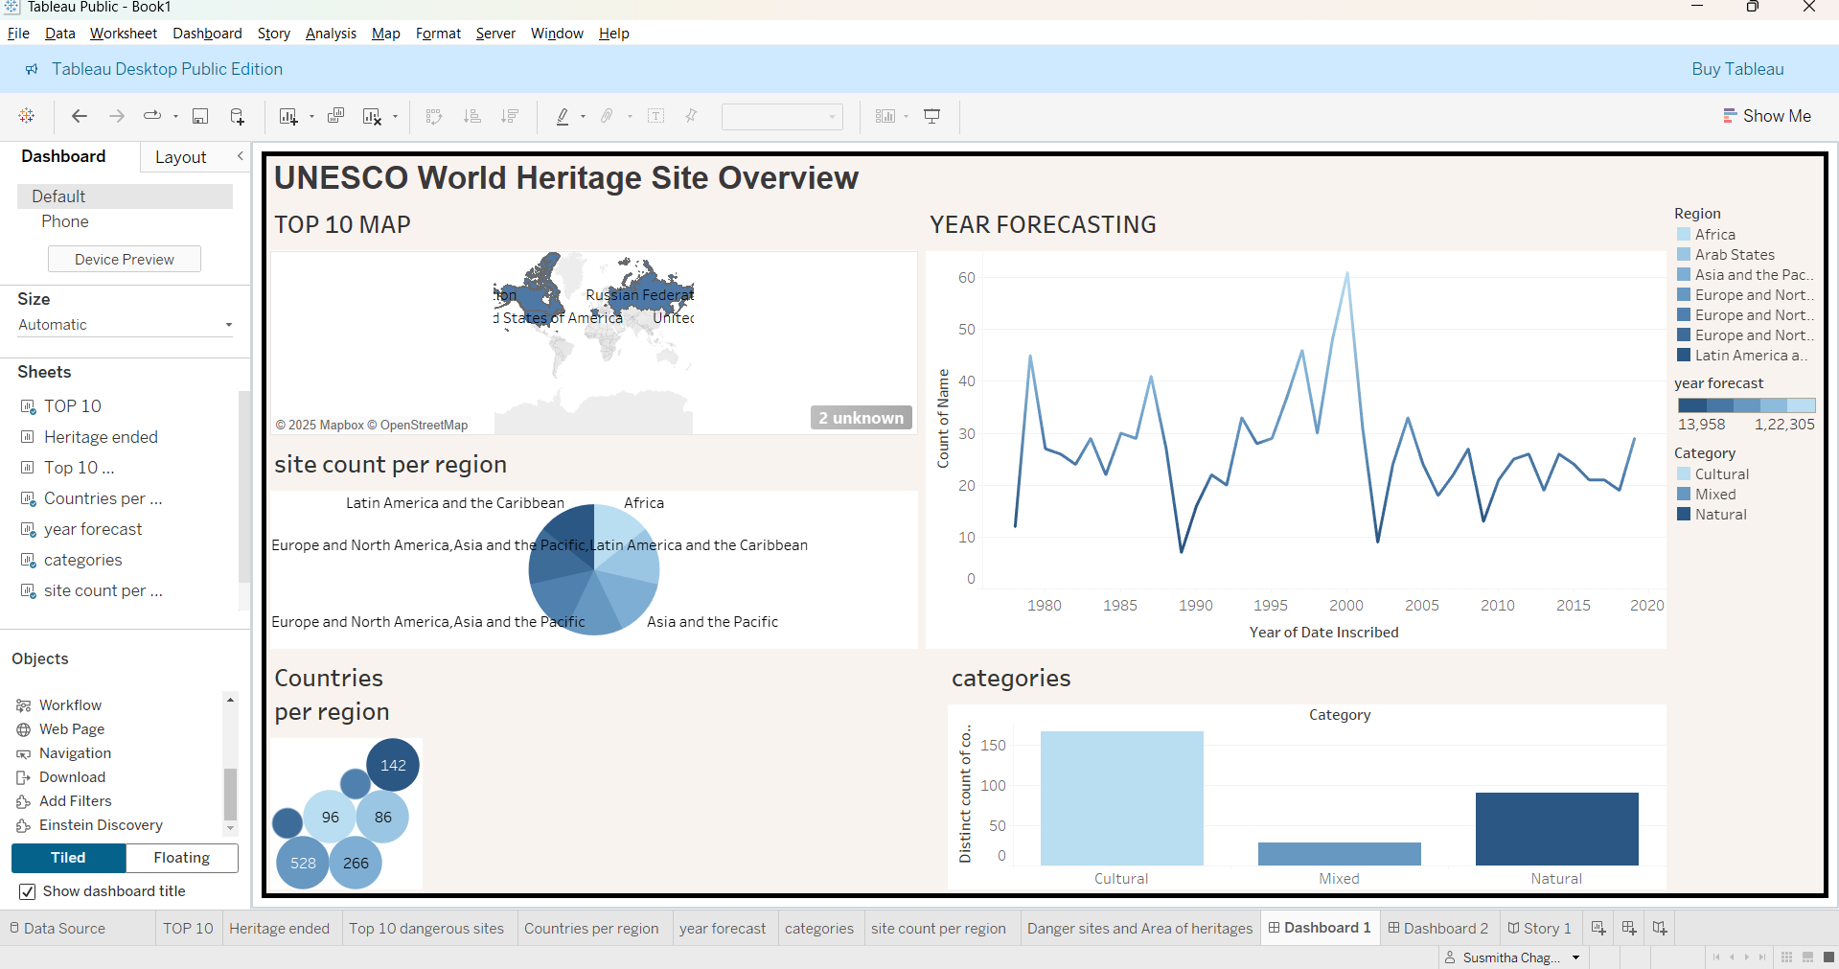

## Final Dashboard2 View

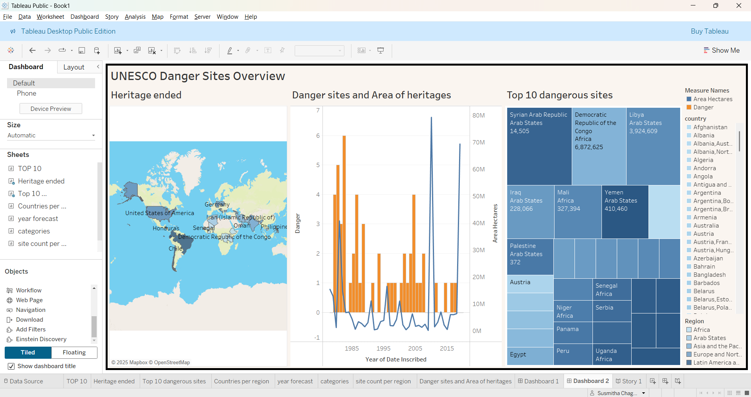

## Story View

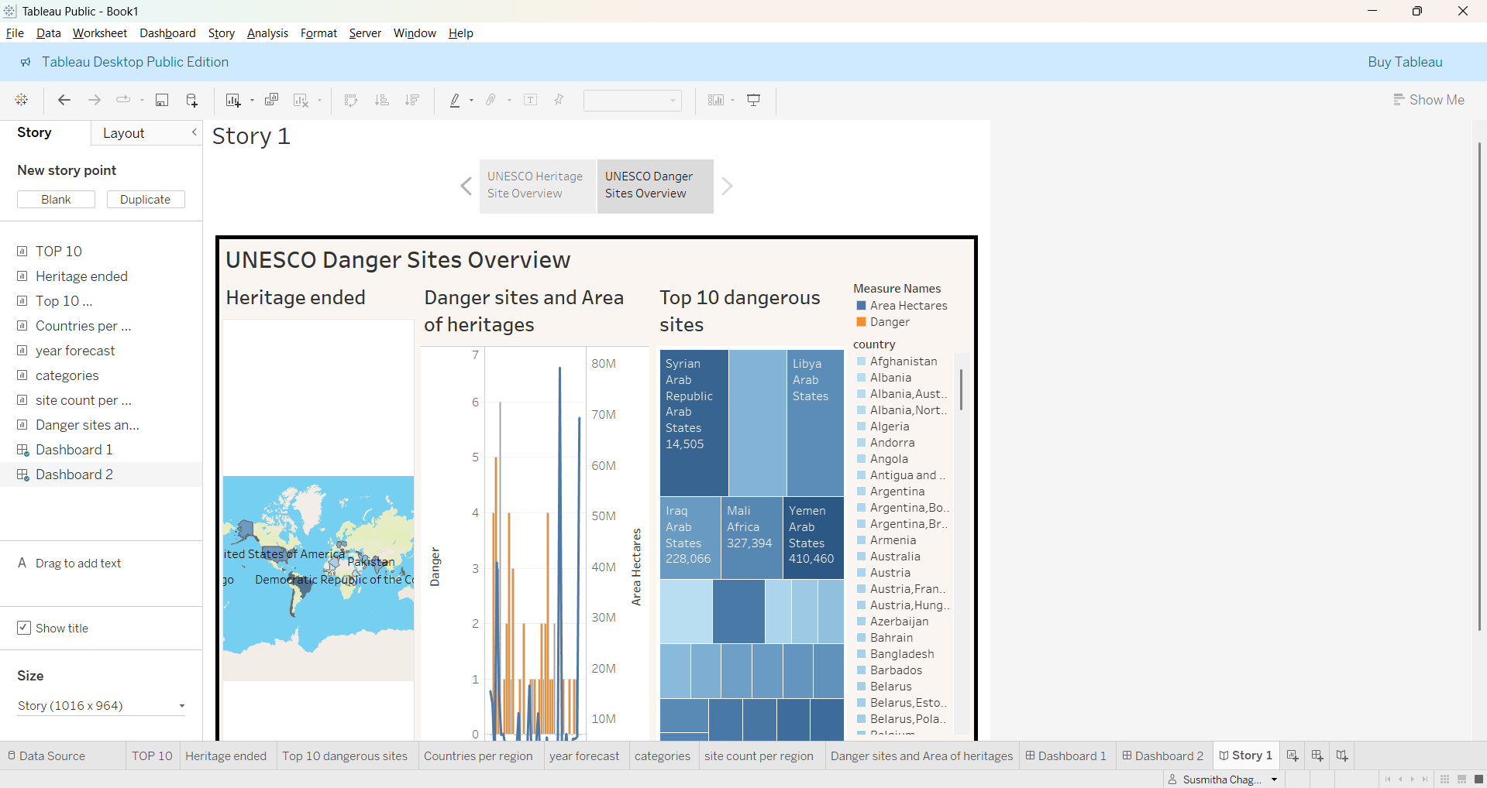

Note: All visualizations were created using Tableau Public and the UNESCO World Heritage Sites 2019 dataset.

**Performance Testing**

**Amount of Data Loaded:**

**Amount of Data Loaded" refers to the volume of data imported into Tableau from the UNESCO World Heritage Sites dataset. The full dataset consists of hundreds of records including attributes like country, region, category, and area, which have been successfully processed and utilized for visualization**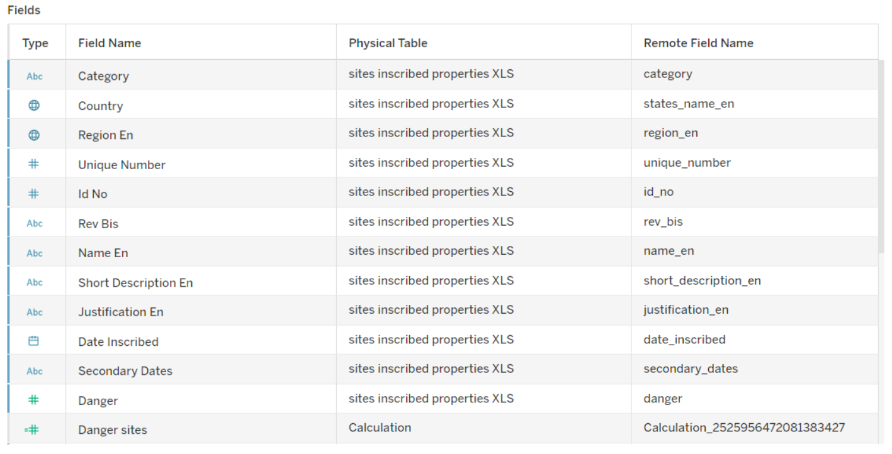

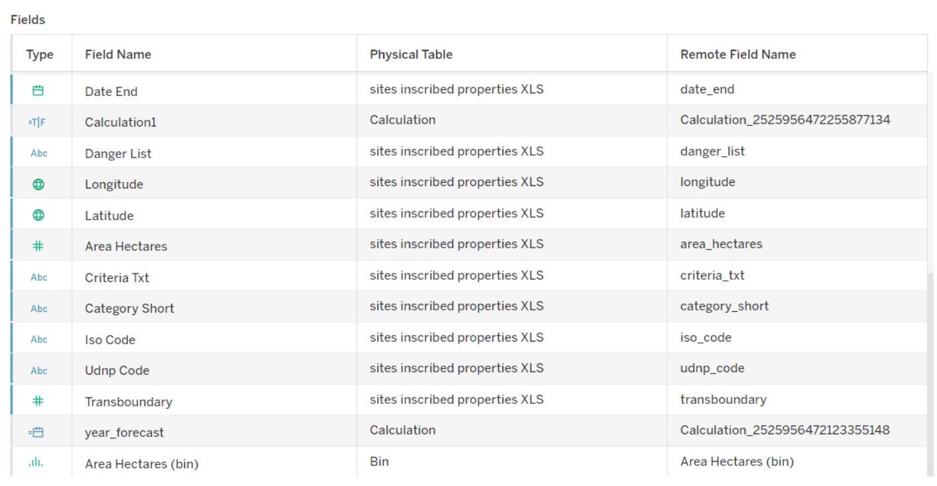

**Utilization of Data Filters**

Various filters were implemented across visualizations, including:

* Region filters (e.g., filter by Asia, Europe, etc.)
* Year filters (to explore inscription timelines)
* Category filters (Cultural, Natural, Mixed) These filters help users customize their view and extract focused insights.

**Activity 2.1: Selected “Latin America” as a filter.** 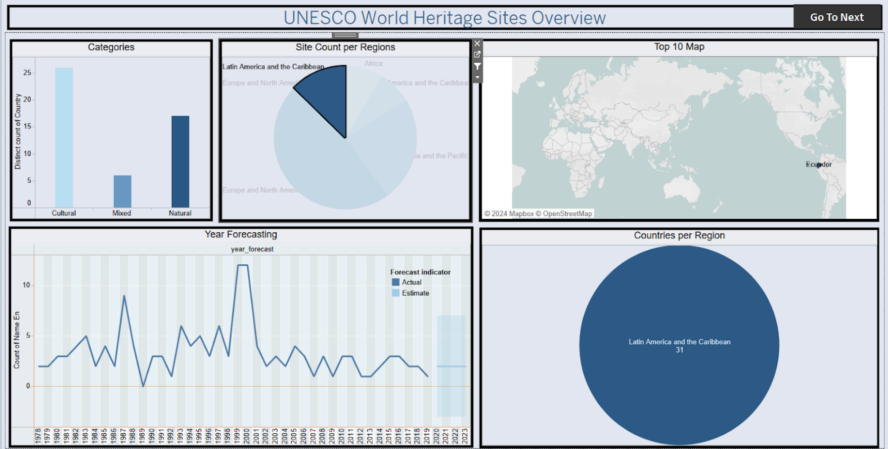

**Activity 2.2: Selected “Europe and North America” as a Filter**

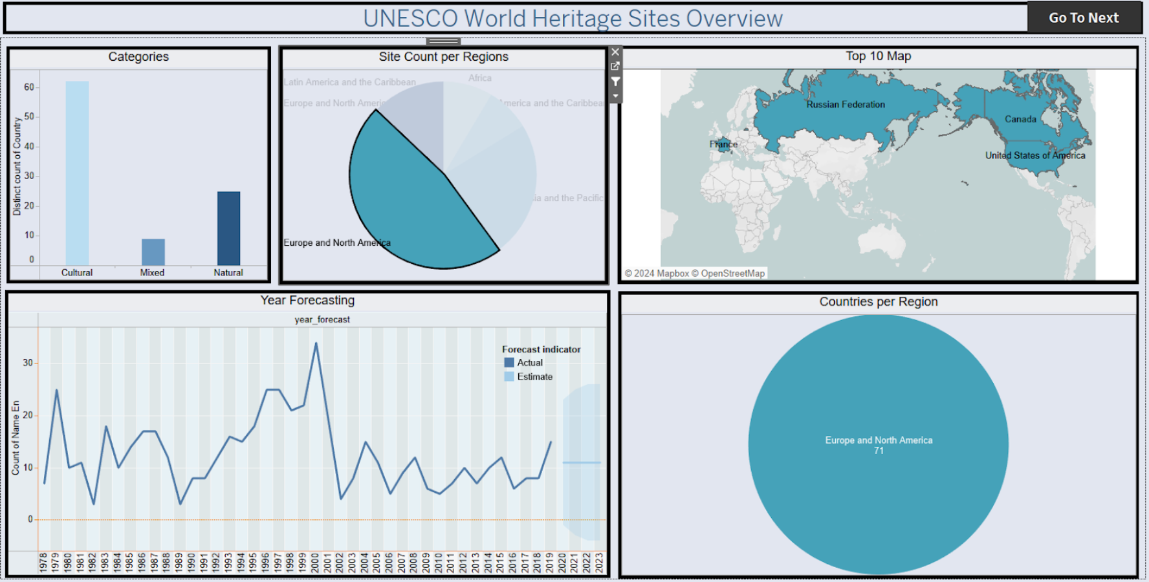

**📈 Number of Visualizations**

This report includes:

* 8 individual visualizations (Activities 1.1 to 1.8)
* 1 final dashboard combining insights
* 1 story sequence guiding the user journey